**Problem Set 3**

This problem set covers material from the first three classes including material from OIS Chapter 2 Section 3.2 to Chapter 4 Section 4.3. It makes use similar data to that we discussed in class. Partial credit may be given for answers that are correct in part, but not in full.

**Part I: Probability (42 pts.)**

1. It appears that the probability of a state voting for a party for president and voting for the same party for attorney general may be related. Based on this seeming relationship, please answer the following questions. I have also provided a contingency table that summarizes the distribution of this data. (32 pts.)

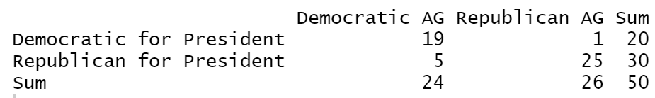

* 1. If you randomly select a state, what is the marginal probability of a state having a Democratic attorney general? Please show your work. (2 pts.)
  2. If you randomly select a state, what is the joint probability of the state having a Democratic attorney general and voting Democratic for president? Please show your work. (4 pts.)
  3. What is the conditional probability of having a Democratic attorney general given that a state voted Democratic for President? Please show your work. (4 pts.)
  4. Does having a Democratic attorney general and voting Democratic for president appear to be independent? (Hint: set the probability of voting Democratic for president as P(B).) Based on this, use the general multiplication rule to find the probability of having a Democratic attorney and voting Democratic for President and discuss how this compares to the probability if they were independent. Please show your work. (6 pts.)
  5. Probability trees are a good way to organize outcomes. Please fill in this probability tree. (8 pts.)

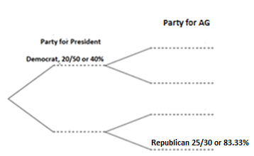

* 1. Using the probabilities you filled in above, please calculate the joint probabilities that apply to the scenarios related to each secondary branch. (Note: you can either fill them in above to the right of what you already filled in or put them here, but if you place them here, please note which secondary branch scenario they apply to below.) Please show your work. (8 pts.)

1. In class, we also discussed whether a state is part of the “Blue Wall.” 18 states are part of the “Blue Wall.” (10 pts.)
   1. The probability of having a Democratic attorney general given that a state is in the Blue Wall is 100%. (all 18 states). What is the probability of a state being in the Blue Wall given that it has a Democratic attorney general? (5 pts.)
   2. In 2016, 83.33% of Blue Wall states (15 of them) voted Democratic for president. What is the probability of a state being in the Blue Wall given that it voted Democratic for president? (5 pts.)

**Part II: Some Normal (or Non-Normal) Questions about Distributions (26 pts.)**

This section makes use of data from the 2012 Election at the state level that the [CQ Voting and Elections Collection](http://library.cqpress.com.proxy.lib.duke.edu/elections/download-data.php) collects and is available through. Duke libraries.

1. Below is a histogram of the percentage of the vote received by President Obama at the state level in 2012 (bin width= 2 percentage point) and a Q-Q plot of the distribution of the data. (26 pts.)

|  |  |
| --- | --- |
|  |  |

1. Does this data look like it follows a normal distribution? Discussing both plots, what evidence is there that the data follows a normal distribution and what evidence is there that it is not distributed normally? (8 pts.)
2. Among the 50 states, the mean Obama two-party percentage is 49.15 and the standard deviation is 10.47. President Obama received 57.86% of the two-party percentage in Maine. What is Maine’s z-score? What is its percentile for Democratic two-party vote? Please show your work or explain how you got the value. (6 pts.)
3. Maine allocates its electoral votes by congressional district. In Maine’s 1st District, President Obama received 60.94% of the two-party vote, while in Maine’s 2nd District he received 54.40%. What is the z-score and percentile for each of these congressional districts? (You can use the same standard deviation as above for the purposes of this problem.) Please show your work or explain how you got the value (in the case of the percentile). (12 pts.)

**Part III: Liddy Dole is 92 (or 93) (12 pts.)**

1. In 2008, the Democratic Senatorial Campaign Committee ran a famed [television ad](https://www.youtube.com/watch?v=LLkazmjpcIs) against Senator— and Duke alum!— Elizabeth Dole (R-NC) accusing her of being either 92 (in terms of the percent of time she voted with George W. Bush) or 93 (in terms of her rank in effectiveness.
   1. Imagine that seven pieces of legislation came up for a vote. Taking the percentage of time the ad claimed she voted with George W. Bush, what is the probability she would vote for all seven? Please show your work. (6 pts.).
   2. Again, imagine that seven items came up for a vote and take the percentage of time the ad claimed Senator Dole voted with George W. Bush. What is the probability that she would vote for two of these items? (6 pts.)
2. National polls are meant to be representative of the country as a whole. On September 2, Selzer and Company/Grinnell College released a [national poll](https://www.grinnell.edu/sites/default/files/docs/2020-09/Selzer%20Co%20GCNP%202219%20Methodology.pdf) with 827 registered voters. What is the probability that this poll includes exactly one respondent from Wyoming? What is the probability that it contains at least one respondent from Wyoming? (10 pts. each; 20 points total). Please show your work.

Some relevant information for this question:

* To simplify this problem, you don’t have to consider non-response or the lack of replacement after a person is polled.
* According to Census data compiled by the World Population Review, there are approximately 268,000 registered voters in Wyoming and approximately 152,666,000 registered voters in the United States.
* Hint: First calculate the probability of a random draw of registered voters including a student from Wyoming.